Company Name
SAWAFUJI ELECTRIC CO., LTD.
Head Office
3, Nittahayakawa-cho, Ota City, Gunma,JAPAN 370-0344
Established Date
May 10, 1919
Capital
1 billion USD (as of March 31, 2019)
Representative Director
Masao Inoue, President
Number of Employees
(Non-consolidated basis)
715 (as of March 31, 2019)
NET Sales
(Non-consolidated basis)
3 million USD (Fiscal Year: April 2018- March 2019)
Main Products
Starters and Alternators for Automobiles, Engine Generators, Engine Welders, Retarder and ENGEL Refrigerators
The Sawafuji Group
(Subsidiaries)
Sawafuji Transport Service Co., Ltd.
ENGEL DISTRIBUTION PTY LTD.
SAWAFUJI ELECTRIC (THAILAND) CO., LTD.

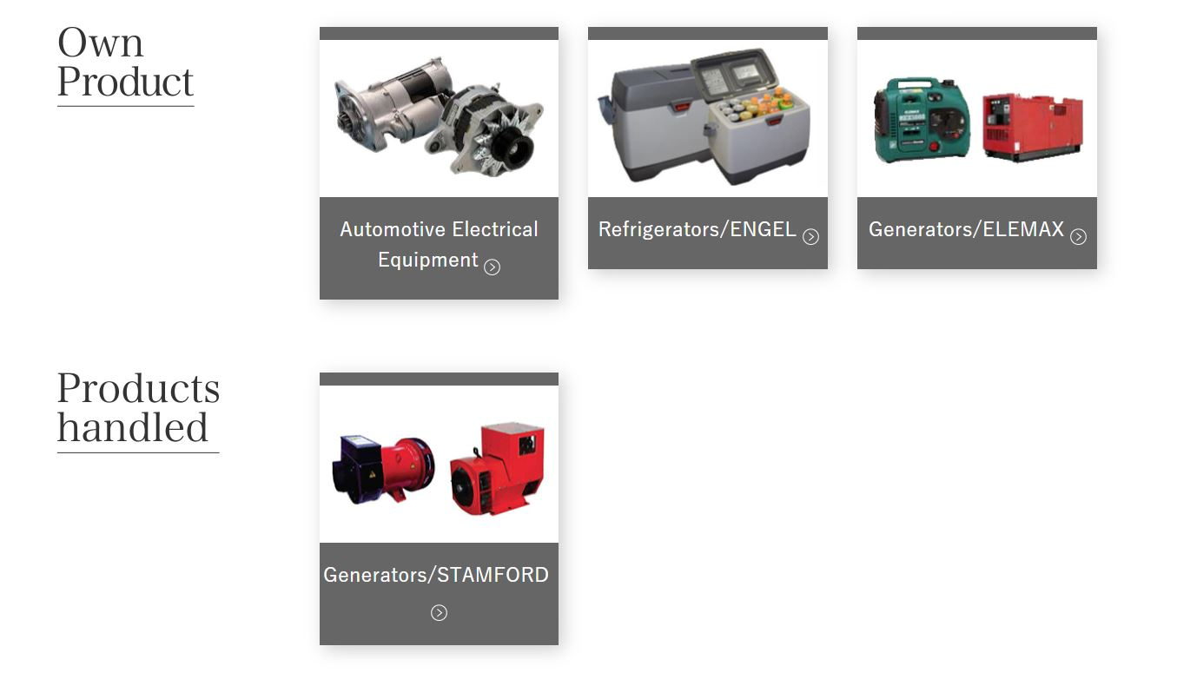

1. Current business and products for the UAE market
→ The company is selling mainly "GENERATOR" that are Gasoline / Diesel type called "ELEMAX" for the UAE market.

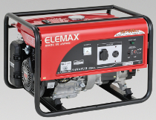 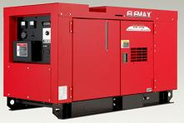
http://www.elemax.jp/products.html
​
Meeting outcomes:

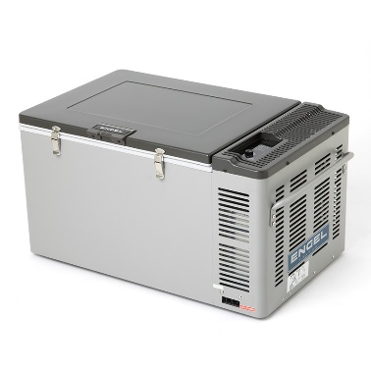
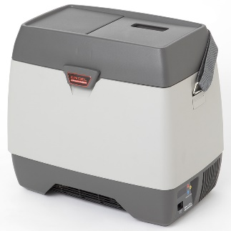
2. Company wants to focus more on
→ "LOCAL UAE STANDARD" in selling the "PORTABLE REFRIGERATOR".
As the company has a long business history of GENERATOR sales in UAE, lining up the PORTABLE FRIDGE sales would be a good business opportunity.

3. The company does not know that we have initially contacted with Sawafuji on request of Ahmad Al Falasi Foundation for Humanitarian Initiatives.
Asked about the company’s current UAE customers and distributers, including their business with Ahmad Al Falasi Foundation.

4. Compliance with UAE Regulations on the Restriction of Hazardous Substances (RoHS).
The Emirates Authority for Standardisation and Metrology (https://manaa.esma.gov.ae) was established as the sole standardisation body in the UAE. The registration of a certain group of electrical and electronic equipment (‘EEE’) with ESMA is required.
RoHS applies to companies importing EEE on the UAE market.
The RoHS regulation also covers Large household appliances; Small household appliances; Consumer equipment; Electrical and electronic tools, etc.
The authorised representative, or supplier, is responsible for the confirmation and acknowledgement that the EEE meets the requirements of the technical regulation.

There is no any restriction/standard for selling electric household items in the UAE local markets, but as a normal rule, the importers/distributers must go through the certification along with a custom clearance.

